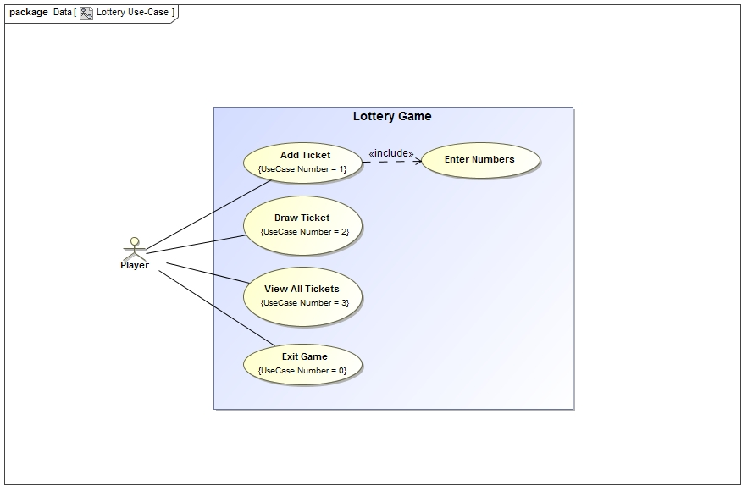

|  |  |
| --- | --- |
| Use – Case | Add Ticket |
| Primary Actor | Player |
| Trigger | Player has selected option “1” from main menu. |
| Pre-Condition | The lottery numbers must not have been drawn. |
| Post - Condition | Return to main menu |
| Flow of Events | 1. The system prompts the user to enter name. 2. The user enters a name. 3. The system prompts the user to enter a first number. 4. The user enters the first number. 5. The system successfully validates the first number. (The number is in a specified range). 6. The system prompts the user to enter a second number. 7. The user enters the second number. 8. The system successfully validates the second number. (The number is in a specified range). |
| Alternative Flow | Condition: Received number out of range. |
| 5a. The number is out of range.  5a1. The system outputs the message to the user.  5a2. Go back to step 4. |

|  |  |
| --- | --- |
| Use – Case | Draw Number |
| Primary Actor | Player |
| Trigger | Player has selected option “2” from main menu. |
| Post - Condition | * The game records random numbers to a special ticket as jackpot numbers. * Menu option “3” (Show Ticket) becomes available. |
| Flow of Events | 1. The system random a first integer within the specific range. 2. The system random a second integer within the specific range. 3. The system successfully compares the second integer with the first integer. (Both numbers are different) 4. The system stores all random numbers to the program. |
| Alternative Flow | Condition: Second number is the same as the first number. |
| 3a1. The second random number is duplicated.  3a2. Go back to 2. |

|  |  |
| --- | --- |
| Use – Case | Show Ticket |
| Primary Actor | Player |
| Trigger | Player has selected option “3” from main menu. |
| Pre-Condition | Lottery numbers have been drawn. |
| Post - Condition | The game displays the lottery number and lists all tickets including the number of hits. |
| Flow of Events | 1. The system compares the drawn lottery numbers with the user’s ticket.  2. The system count the number of correct hits  3. The system displays the drawn numbers, player tickets and the number of correct hits on the screen. |
|  |

|  |  |
| --- | --- |
| Use – Case | Exit Game |
| Primary Actor | Player |
| Trigger | Player has selected option “0” from main menu. |
| Post - Condition | The program terminates. |
| Flow of Events | 1. Display a thank you message.  2. Terminate |